**COMPLEXITY SCORING**

A value of 1 to 5 will be assigned (scored) to the various parameters in order of their decreasing effects on recovery factor. That is, an assigned value of 1 to a particular parameter will show a higher influence of that parameter on the recovery factor. The trend decreases from 1 to 5 with a score of 5 bearing the lowest effect on the recovery factor.

1 > 2 > 3 > 4 > 5



Decreasing effect of parameter score on recovery factor

|  |  |  |  |  |  |
| --- | --- | --- | --- | --- | --- |
| **Field scores** | **Recovery Factors %** | **Structural compartmentalization** | **Viscosity** | **Areal density** | **Vertical reservoir heterogeneity** |
| Auk | 18.0 | 3 | 1 | 3 | 5 |
| Brae S | 33.0 | 3 | 1 | 1 | 3 |
| Brent | 52.3 | 2 | 1 | 1 | 2 |
| Captain | 32.0 | 2 | 3 | 2 | 1 |
| Don | 10.5 | 5 | 1 | 1 | 1 |
| Forties | 57.0 | 1 | 1 | 1 | 2 |
| Fulmar | 69.0 | 1 | 1 | 1 | 2 |
| Heather | 31.0 | 2 | 1 | 3 | 4 |
| Hutton | 35.0 | 2 | 2 | 2 | 1 |
| Hutton NW | 26.0 | 2 | 2 | 3 | 4 |
| Magnus | 50.0 | 2 | 1 | 1 | 1 |
| Maureen | 55.0 | 1 | 1 | 2 | 2 |
| Montrose | 41.0 | 1 | 1 | 4 | 3 |
| Ninian | 46.0 | 3 | 1 | 2 | 2 |
| Rob Roy Supra | 56.0 | 1 | 1 | 2 | 1 |
| Rob Roy main | 67.0 | 1 | 1 | 1 | 1 |
| Thistle | 49.0 | 2 | 1 | 1 | 3 |
| Claire | 14.0 | 5 | 2 | 1 | 1 |
| Mariner Maureen | 18.2 | 4 | 3 | 1 | 1 |
| Mariner heimdal | 14.2 | 3 | 4 | 1 | 1 |
| Bentley | 17.9 | 3 | 5 | 4 | 1 |
| Bressay | 25.0 | 1 | 5 | 1 | 1 |
| Arbroath | 50.9 | 1 | 1 | 3 | 3 |
| Arkwright | 34.2 | 2 | 1 | 3 | 1 |

### SUMMARY OF SCORING APPROACH

The table below summarises the scoring approaches selected to be used in this study:

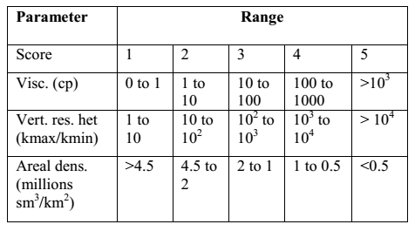

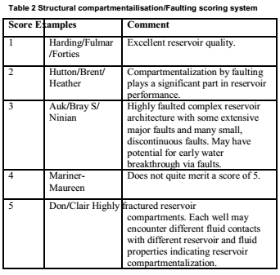

The **scores** for the various factors are the **inputs** and the recovery factors are the **outputs** for the artificial neural network model.

**FLOW CHART OF PROJECT**



**Prediction**